T3.21.3 Method (c) – Combine the Standard Impact Attenuator peak load of 95kN with the wing mount failure load calculated from fastener shear and/or link buckling.

Target: Fasteners must shear under 25kN or 5620.22lbf. Factor of safety must be less than 1.

Revised sections are highlighted yellow.

Bolt: ¼ - 20 x ¾ in UNC-2 Grade 2 Hex Head Bolt

N = number of bolts (SINGLE SHEAR) = 4

F = force = 5620.22lbf

FS = factor of safety

At = tension area

τ = shear stress of bolt

At = 0.0318 in2

τ = 0.577 x tensile stress

Tensile stress of SAE grade 2 bolt = 74,000psi

τ = 42698psi

Fallow = τ \* At \* N= $42698\frac{lbf}{{in}^{2}}*0.0318 {in}^{2}*4$ = 5431.19lbf

$$FS= \frac{F_{allow}}{F}= \frac{5431.19lbf}{5620.22lbf}=0.966$$

The factor of safety is less than 1; therefore the bolts will shear under 5620.22lbf.

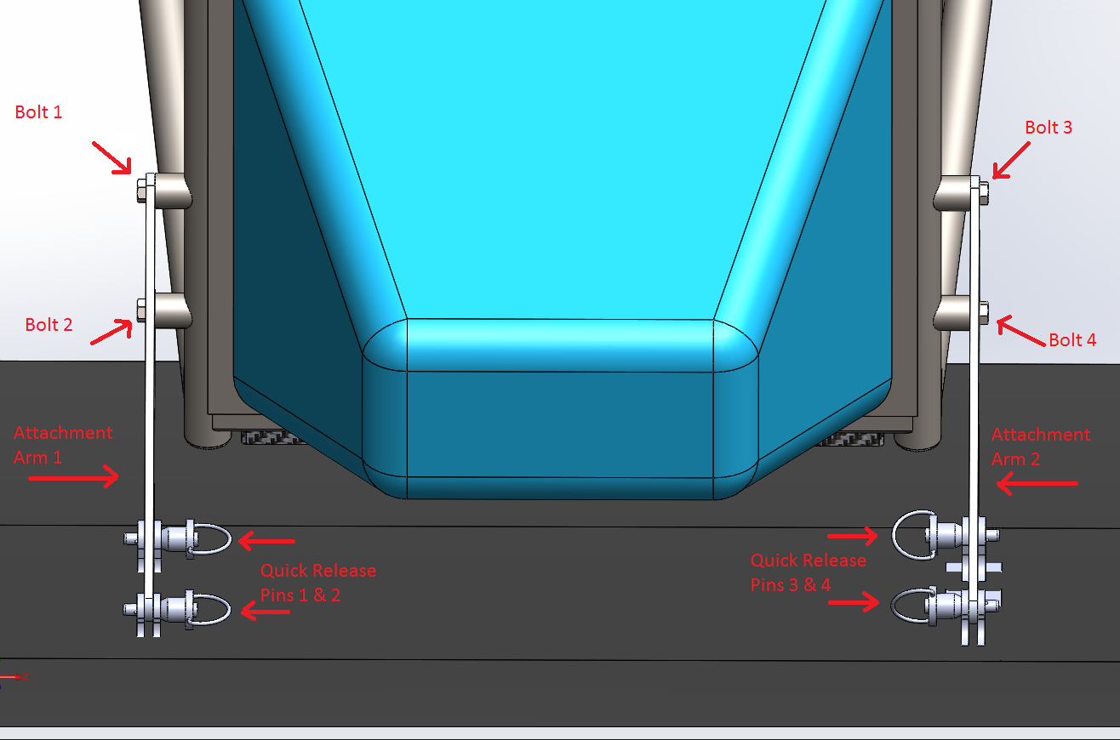

* There are 4 bolts (¼ - 20 x ¾ in UNC-2 Grade 2 Hex Head Bolts) in single shear that hold the aluminum attachment arms to the chassis. They bolt in to threaded pickups welded to the chassis. These four bolts are the designed mode of failure to comply with rule T3.21.3.
* There are 2 aluminum brackets that are integrated into the front wing during the carbon fiber layup.
* The attachment arms are connected to the brackets with quick release pins. These pins are not designed to fail due to shear.